April-June, 2017
Volume 8, Issue 2
Innovative Improvised Solutions
Insights into Enhancing Mental Agility!

By Adam Sietz

Recent Articles based on the successful applications of Improvisation:

• A great story about MIT students and their use of Improvisation:

“Business School Better Preparing Tomorrow’s Leaders In The Art Of Pulling Stuff Out Of One’s Ass”
http://tinyurl.com/2dyfofy

• A wonderful article on how a group of people are using improvisation to help autistic children.

“Improv for autistic teens”
http://tinyurl.com/2949p7f

• Science proves the benefits of Improvisation training thorough Innovations in teaching.

“Improvisational Exercises to Improve Pharmacy Students' Professional Communication Skills”
http://tinyurl.com/26fgbh4

• Groupon’s Innovation through Improvisation.

“Tour Groupon, The Funniest Startup We've Ever Been To”
http://tinyurl.com/22ktd7e

* * *

Table of Contents:
Innovation & Creativity 2
5 Rules of Improv 2
Working out Your Brain 3
Humor & Laughter 3
Take the Scenic Route 4
Be a Better Storyteller 4
Let go of Ego & Status 4 Finding the Offers 5
Benefits of Improv 6

Why do we do what we do? For me, everything I do in my working life comes down to one thing. “Will this make me happy? Can I find passion in this?”

Money can help to get you more stuff and yes money is a great tool to help get things done, but the evidence is in. Money will not and cannot buy you happiness.

On the other hand, your happiness can attract a lot more than money. The best way for me to achieve this state of happiness is to stay in the present.

By staying in the moment and getting out of my own head, I find myself in a much better mood, I get more accomplished in less time and one great added byproduct is…I often find my happiness level is infectious.

The state Happiness is hindered by our allowing our thoughts to control us.

The truth is, we control our thoughts. Too often our own inner thoughts get squashed down and wiped away due to our own self judgment. Our Goal is to help you and your business, classroom, team, family, friends and any other accomplices in your life go to war with these negative thoughts, and win the battle each and every time!

Staying in the NOW will lead you to your HAPPY PLACE

. . . and help others to find there’s more often

Improvisational thinking opens doors & closes deals!

There is an old saying my mother has always said to me: “Man Plans and God Laughs”. We have all been in a situation where we knew what was set to happen and then…all bets are off and the plan falls apart. We could react with fear and disappointment, or we can improvise and set a new path. Instantly!
The skills and tenets of improvisation help to foster that ability to think on your feet, adapt and overcome newly realized obstacles. Instead of wanting to run away you can become the savior, the hero, the one that saves the day. In the past, and so often, a clear idea or thought will enter my mind. I will then start to evaluate and begin to judge the thought. By the time I am ready to act on the thought it’s too late the train has left the station. Innovation comes from thinking out of the box, taking risks and trusting your gut instincts.
I can relate story after story of how many people have achieved success in their personal life and career life due to their previous, experience and skill set learned through the tenets and exercises
of improvisation. Over and over again it has been my ability to Improvise that has helped me close the deal or land the role or just simply get me what I want.
I was fortunate to have the opportunity to perform on Broadway, but get this; I had never acted in a play before. How did I pull this off? By pulling it out of my …in other words, I used my Improvisation skills! I just acted as if and when the director asked me: “what theatre I had done before”, I simply took a moment to think it out and then I reframed my answer to fit my end goal. Curtains Up!

Unleash True Innovation and Creativity with Improv
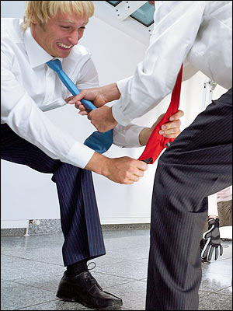

Too often, innovation and creativity are stifled in the standard long established parameters already laid out throughout the many years of commerce and business practice.
For example, let’s look at “Roberts Rules of Order”. I remember as the new President of my Condo Community Association, I read “Roberts Rules”. Yes, they did make sense. Meetings were kept under control, we the board members, were not held captive for hours being sweet talked or abused (more often the latter) by the attending citizens of the community and at times, we did get some things accomplished.
I had a problem with this formulaic and at times, strict framework in which the introduction of new ideas and concepts must follow guidelines set in place by a book written over 135 years ago.

Just before I was elected, I was just an audience member. I found myself and many other people leaving these board meetings bored. We often felt we were unheard, unhappy, unimportant and unfulfilled.

By allowing the sitting board members and attending citizens to have the opportunity to speak up in the moment (within reason) most of the fighting stopped. The meetings became more productive, a lot more enjoyable and…I got my new shrubs and a resurfaced tennis court

goal in distributing a newsletter might be to sell your product or service, the key to a successful newsletter is making it useful to your readers.
A great way to add useful content to this newsletter is to develop and write your own articles, or to include a calendar of upcoming events or a special offer that promotes a new product.
You can also research articles or find “filler” articles by accessing the World Wide Web. You can write about a variety of topics, but try to keep your articles short.
Much of the content you put in your newsletter can also be used for your Web site. Microsoft Word offers a simple way to convert your newsletter to a Web publication. So, when you’re finished writing your newsletter, convert it to a Web site and post it.

“To have the opportunity to speak up in the moment,
(within reason) the fighting stopped and the meetings became more productive and a lot more enjoyable.”
Rule #1: YES, AND! Stop saying NO so quickly. Instead think “YES, AND”. This concept helps to lay the foundations of Improv. This fundamental formula of starting with a Yes, will often help to open up and reveal useful information to you. For me, by always saying yes at first, I find it allows me to take time to accumulate more valuable information to make a thoughtful, in-depth decision. Whoever said I can’t change my mind and politely say No at a later junction. By getting into the habit of saying Yes, now and then building on the initial thought by adding …AND…I have been and you will be blessed to witness true unleashed innovation and creativity thrive!
Rule #2: LISTEN FIRST THEN THINK. As you already know, focused listening is so important. If you are busy thinking about what you want to say next or what you forgot to say before, you cannot concentrate on the input coming at you. Listen first, get where they are coming from before you speak.
Rule #3: AVOID ASKING QUESTIONS. In the business world and in life, when we take time to ask a lot of questions, we often end up making the other participant(s) do all of the work. I am not saying ask no questions, just be conscious of how you can make statements instead. How you can frame your statement in a way that covers your intended goals.
You may also find when someone asks you a question and you instantly know if you answer the question truthfully as asked, it can hurt - not help your cause, you can find ways to reframe the answer to fit your needs and many times this maneuver fulfills the need of the questioner without having to be untruthful.
Rule #4: EYE CONTACT & PAY ATTENTION
Focused attention is hard to keep. Distractions can take you off the track and out of the game. Body language or just a simple look on someone’s face can instantly communicate a feeling of like or dislike.
Even when you are on the telephone, you can sense and pick up on the cues, clues and the tone and or demeanor of the other person
Rule #5: ADD INFO.
If you yes and, you add information, building on the idea. By contributing, you can get things to go in the direction you want them to go.

5 Simple Rules of Improvisation



“Even when you are on the
Telephone, you can still sense
and pick up on the cues, clues
and the tone or demeanor
of the other person”

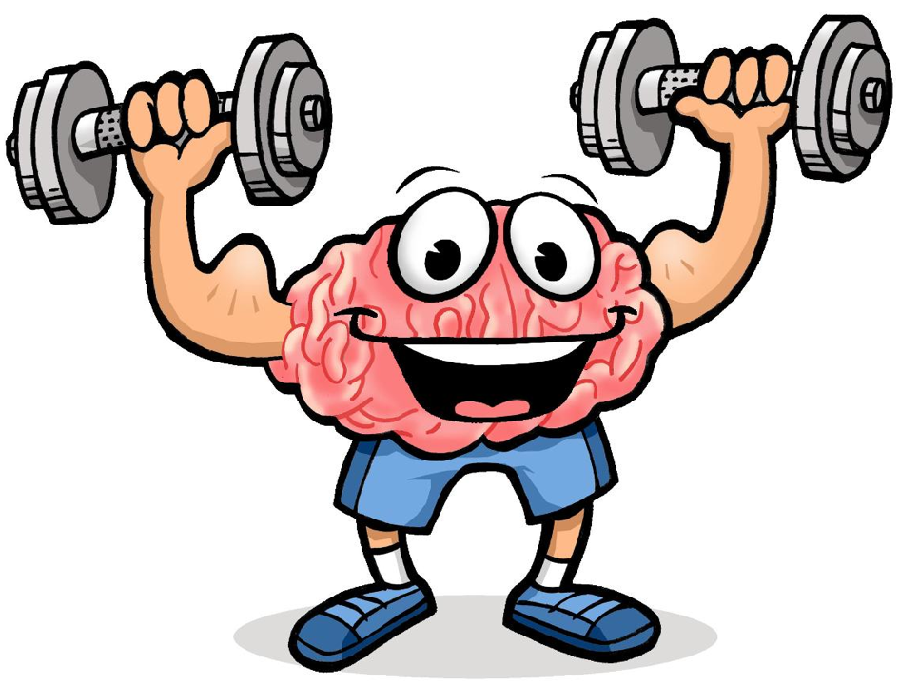
Ca
Weightlifting and physical exercise can build the muscles in your body; improvisation does the same for your mind. Either in a group setting or on a one on one basis, you can work/play with others and grow your mind muscle. This is a workout that you will enjoy, a brain workout.

Improv based games and exercises force the mind to work on a quick action basis. This quick wit ability helps us to connect with others. Tapping into the skills gained through Improvisation training helps you think faster and act better on your feet.

In trusting your guts initial instincts, you can allow your imagination; instant thought impulses see the light of day. You will open up your mind, gain confidence and awaken your inner child.

There are no rules. There are no props or machines needed. There is no such thing as right or wrong in this healthy, creativity enhancing and innovative improvising methodology.

The main component is being completely present and in the moment. This way, any self limiting thoughts and wasteful self judgment rising up, cannot get in the way of a good workout and having fun.

One way to exercise your brain is to play games.

After years of study, it has been scientifically proven that play keeps you healthy and happy. In fact here are some fancy more clinical words explaining it:

“Play engages and works the prefrontal cortex, responsible for your highest-level of cognitive functioning – including self-knowledge, accessing your memory, mental imagery, and incentive and reward processing…” Besides the Improvisational games and exercises, activities like bridge, chess, sudoku, role-playing games, and challenging crossword puzzles all provide rigorous neural workouts”.

“If and when you make someone smile, you will gain their attention…If you can make someone chuckle, you not only have their attention, they will now actually pay attention to what you have to say…If you can get them to laugh, well then you can sit on their lap and close the deal!”


Working out your Brain: Mind Exercises & Games

Another bonus to knowing the art, skills and tenets of improvisation is improv often helps you find humor in your daily life. You do not have to be funny to evoke humor. Humor is truth revealed.

Who doesn’t like a laugh? Nobody I know. Laughing is an involuntary reaction. In most cases, we only laugh when something or someone does something that instantly stimulates our senses to react in a positive way. No one has ever said I didn’t have fun while I was laughing. Any walls are normally broken when you can get someone to laugh! It says to another person …ok were cool. Their defenses are let down and a smile is always accompanying the laugh you touch their soul.

Years ago, my father shared with me the following valuable advice:
“If and when you make someone smile, you will gain their attention…If you can make someone chuckle, you not only have their attention, they will now actually pay attention to what you have to say…If you can get them to laugh, you can sit on their lap and close the deal!” OK maybe not, but I think you get the point.
In your next meeting, try saying: “You want to hear a joke?” If they say yes, A) Make sure you have a good one and B) Keep it clean (unless you know your audience wants it dirty). When they laugh, even if only for a moment, Status, Ego and the Need for Control and Power are instantly removed. This is how kings and citizens bond. The court jester was always nearby to help the king get into a good mood….or if not, he was an easy kill! Off with his head! Why would a chicken cross a road anyway!? Laughing will create smiles. Smiles = Happy. Happy is good!

Ha ha ha! Laughing your way to Success


“The view on the scenic route is where I found my “Evergreens!”

Salesmanship: “The Ship of Sales” Can Always Afford the Time Spent “Taking the Scenic Route”

When I was just starting out in the business world, I was a “Salesperson”. I began in a large Music & Electronics Retail Store I then moved onto Media and eventually became the product and embarked on a new career selling myself. By having a strong background based in improvisation, I was able to quickly develop and truly enhance my sales skills (and my stores sales profitability). I soon found when I would take a more personal approach or what I like to call “Taking the Scenic Route” with the client, we would connect on a higher level and they would return again and again. If you see an opportunity to get off the direct express track ending in the sale, take it. I have always found that The relationship took on more meaning when and if I could find a way to commune with the other person(s) in some mutually connected way or even a random thought somehow triggered in my mind. The view on the scenic route is where I found my “Evergreens!”

Everyone loves a good story. Don’t you? Life is just one big story. You are living a story. The truth is, we’re all story tellers.

If you feel comfortable, tell a story in a meeting, a sales phone call or even on a first date, try to become the characters. It’s better than saying he said____, she said____. People love when others can change their voice. You do not need to be a VO artist. Just contrast your voice a bit for each character involved. And most of all, know your story, get to the point and make sure it’s a worthy interesting story.

Do your best to help them feel like they are a part of it. Take the extra time to help create the visual in their imagination. You can use the listener’s sense memory to immerse them into your story. Vividly describe some of the smells, feelings, tastes, colors, textures, mix in an environmental detail or two, and then, blow them away by becoming the Characters voice too.

“Let go of your ego and forget about any need or desire for Status!”
In improvisation Status and Ego only get in the way. Let go of your ego and forget about any need or desire for Status! In my personal opinion, both are pure fantasy! Both are worthless to your soul.

Status seeking is an extrinsic self centered behavior. Yes it is a normal occurrence in the natural world. But, to me status does absolutely nothing for your-self, other than help to stroke our weak unattractive egos!

In the past, status was based on what you do or what you have done or contributed. Now, it is based on what and how much you have, $ and possessions. Do not get me wrong, a shiny new convertible Porsche and a wife happily covered in diamonds is OK. It just is not import to the rest of the world. Now on the other hand, walking in off the street and getting a table for sixteen at Peter Lugar’s Steakhouse when they claim to have no tables until June…doesn’t suck.

If someone else chooses or wants to give you status for some silly reason of their own (you have money, a cool car, a beautiful face or body, your job description has you signing autographs, etc.) Go right ahead, capitalize! And then, enjoy the Porterhouse!

Become a Better Storyteller: Become the Character

Living Free Without Ego and the Need for Status

Finding the Offer in Anything

The way to implement improvisation in your daily life and any other arena, stage, classroom, office or boardroom is simple:

You must be completely in the moment. You must be ready to accept any offer that comes your way. You may be wondering: “What the heck is an offer?” An offer can be a physical action or a word (your own or someone else’s). An offer may be a particular image/picture that pops in your mind’s eye or one you notice on the wall or on the face of the person listening to you as you plow ahead with the next word in the sentence.

Generally speaking with most performance related, scene based improv, nothing happens without the players accepting the initializing offer. The team of actors begins by getting a suggestion from the audience or host. One player jumps up and makes an “Offer” to start the action. Player two accepts the offer and adds to it. “Yes and…” They both continue helping, building and assisting each other in creating a Who? What? Where? Why? and How? As the game moves forward, each player continues to make and accept each other’s offers and additions.

Find the offers that come out of your mouth and materialize from your own words…What do I mean by this? As we speak…we are constantly pulling information from our brains filing cabinet. This happens in mili-fractions of a single second. As they come out, be conscious to look for those spots where you can insert a silly contrast or odd replacement. This will also help mine for the humor to find the funny.

“…accept each other’s offers and additions”.

What are Some of the Benefits of Improvisation?

“Once l was proficient enough to truly utilize the tenets and skills of improvisation, all aspects of my life dramatically improved.”

Helpful Improv Websites:
yesand.com
improvencyclopedia.com
learnimprov.com
fuzzyco.com
greenlightwiki.com

A simple Google search using the above headline will fill your reading list for the next 25 years. Once l was proficient enough to truly utilize the tenets and skills of improvisation, all aspects of my life were dramatically improved. Through games, exercises and if you have it in you, a performance, you will touch upon Artistic, Theatrical, Educational and Successful Life and business factors including the following:

Working out both your Right and Left Brain

Focused Communication

The Importance of Eye Contact

Public Speaking
Confidence Building

Extreme Concentration

Teamwork &
Team Making

Listening Skills

Creative Thinking

Give and Take

Making Strong Choices

Commitment

Comfort in Risk Taking

Dealing with Adversity

Acceptance

Increased Authenticity

Exploring Feelings and Emotions

Intuition / Trusting Your Gut Instincts

Self Esteem

Refine Brainstorming Abilities

Inclusion of All

Goal Setting

Presentation Skills

Comfort in Social Settings

Improved Relationships

Fosters Trust

Ability to deal with change

Think Quickly Under Pressure

Let go of the need to Control

Conflict resolution

Creatively Find Solutions

And much, much more!

Improvisational training is great for actors, but you do not need to be one.
Recent research studies conducted by Keith Hmieleski and Andrew Corbett reveals that entrepreneurs and business leaders choose to use various proven improvisational tactics in their processes when resources, like time, are limited and challenges are high. Their extensive research clearly showed that improvisation, in the right situations, is a highly successful strategy.
Frank Ruffs’ detailed research on organizational improvisation published in Future magazine in 2004, states that improvisation is an important strategy for corporations to deal with “wild card” or unforeseen crises and unpredicted change. Improvisation, as a strategy for dealing with the unknown, is also utilized by EMS workers, police, military, firefighters and security personnel. We can also witness the fine art of improvisation in theatre and music, particularly Jazz and Blues.
In sales terms, think of improvisation as being intentionally flexible on how to reach a goal. Knowing what your current state is and where you want to be is important, but which path you take will depend on the circumstances of the moment. This is much harder than it sounds because it relies on giving up the attempt to control.
You’re a creative person with many ideas that want and need to come out now! An Improvisation based class (workshop, day retreat, training or team building seminar) is a great way for your people to truly meet and improve communication between the different groups within your company. From the Executive team to the Janitorial staff, everyone is important and included. Everyone gets to play.
There are companies that have different divisions that may feel a sense of competition or never even communicate with each other. Maybe they feel they just don’t have the need or because they have become adversarial over time.

Improvisation helps to create a friendly social atmosphere. It helps your team “break the ice”, break free from the grip of uncomfortable shyness and improves their skills for press interviews, meetings with new clients or even first dates! Through improv exercises and fun energetic games played in a relaxed and supportive environment, true bonding can be established. Once you have played with someone, the dynamic of the relationship is bound to change for the better and everyone will walk away with a sense of freedom, happiness and empowerment that only this art form can bring!

Why Should an Organization Utilize Improvisation?


(A Division of SEM/BIG HUG)

323 Blauvelt Road
Blauvelt, NY USA 10913

Phone:
(917) 972.5252

E-Mail:
info@improvolutions.com

To find out more about
what we can do for you,
call or email us anytime.

We look forward to
hearing from you

We’re also on the Web!
Come visit us at:
www.improvolutions.com

323 Blauvelt Road
Blauvelt, NY USA 10913

To:

